 |  |  |  | User/Technical Manual | Approved by Production Dept.
 |  |  |  | User/Technical Manual | Checked by Quality Assurance Dept.
 |  |  |  | User/Technical Manual | Prepared by Engineering Dept.
Type No. |  |  |  |  | Date | 2004/04/20
APPROVAL

SALES MANAGER

 |  |  | Table of Contents
 |  | 1. | General Specifications |  | ………………………... |  | 2
 |  | 2. | Mechanical Diagram |  | ………………………... |  | 2
 |  | 3. | Interface Pin Connections |  | ………………………... |  | 2
 |  | 4. | Block Diagram and Power Supply |  | ………………………... |  | 2
 |  | 5. | Absolute Maximum Ratings |  | ………………………... |  | 3
 |  | 5.1 | Electrical Absolute Maximum Rating |  | ………………………... |  | 3
 |  | 5.2 | Environmental Absolute Maximum Rating |  | ………………………... |  | 3
 |  | 6. | Electrical Characteristics |  | ………………………... |  | 3
 |  | 7. | Electro-Optical Characteristics |  | ………………………... |  | 3
 |  | 8. | Timing Control |  | ………………………... |  | 4
 |  | 9. | Instruction Set |  | ………………………... |  | 4
 |  | 10 | Description of Instructions |  | ………………………... |  | 5
 |  | 11 | Initialization and Programming |  | ………………………... |  | 6
 |  | 12 | Reliability Condition |  | ………………………... |  | 6
 |  | 13 | Function Test & Inspection Criteria |  | ………………………... |  | 7

1. GENERAL SPECIFICATIONS
ITEM | STANDARD VALUE |  |  | UNIT
Number of Characters | 128 DOTS x 64 DOTS |  |  | --
Controller IC | KS0108 |  |  | --
LCD Polarizer | STN Transmissive, Negative Blue
Module Dimension | 93.0 (W) x 70.0 (H) x 12.0 (T) |  |  | mm
Display Viewing Area | 72.0 (W) x 39.0 (H) |  |  | mm
Display Active Area | 66.52 (W) x 33.24 (H) |  |  | mm
Dot Size | 0.48 (W) x 0.48 (H) |  |  | mm
Dot Pitch | 0.52 (W) x 0.52 (H) |  |  | mm
LED Backlight Color | White
LED Backlight Input | DC +5 | V | 90 | mA
LED Backlight Life Time | 20,000 |  |  | HRS

2. MECHANICAL DIGRAM
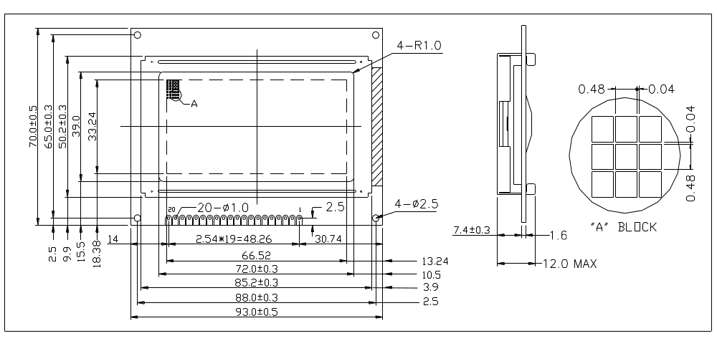

3. INTERFACE PIN CONNECTIONS 4. BLOCK DIGRAM AND POWER SUPPLY
NO | SYMBOL | FUNCTION | 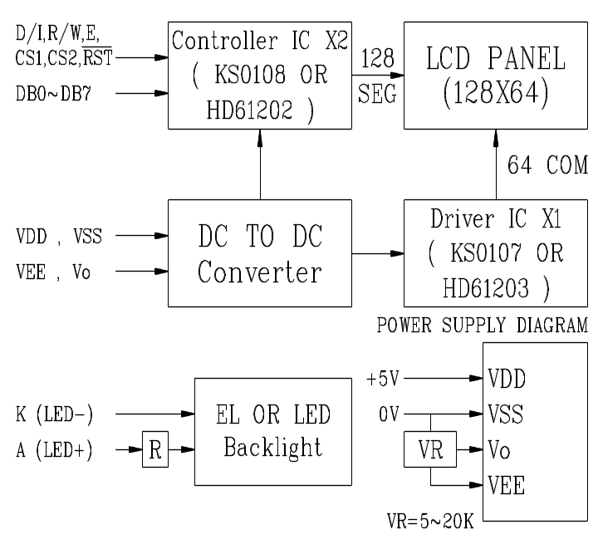
1 | VSS | Ground (0V)
2 | VDD | DC +5V
3 | Vo | Contrast Adjust
4 | D/I | Data/Instruction
5 | R/W | Read / Write
6 | E | Enable Signal
7 | DB0 | Data bus line
8 | DB1 | Data bus line
9 | DB2 | Data bus line
10 | DB3 | Data bus line
11 | DB4 | Data bus line
12 | DB5 | Data bus line
13 | DB6 | Data bus line
14 | DB7 | Data bus line
15 | CS1 | Chip 1 enable signal
16 | CS2 | Chip 2 enable signal
17 | /RST | Reset Signal
18 | VEE | Negative voltage output (DC -5V)
19 | A | LED +
20 | K | LED –

5. ABSOLUTE MAXIMUM RATINGS
5.1 Electrical Absolute Maximum Rating
ITEM | SYMBOL | MIN | TYP | MAX | UNIT
Logic Circuit Supply Voltage | V_{DD} - V_{SS} | - | 5.0 | 6.5 | V
LCD Driver Circuit Supply Voltage | V_{DD} - V_{EE} | - | - | 10.0 | V
Input Voltage | VI | VSS | - | VDD | V

5.2 Environmental Absolute Maximum Rating

ITEM | OPERATING |  | STORAGE |  | COMMENT
ITEM | MIN | MAX | MIN | MAX | COMMENT
Ambient Temperature | 0˚C | 50˚C | -10˚C | 60˚C | Note (1)
Humidity | Note (1) |  | Note (2) |  | Without condensation
Vibration | -- | 4.9m/s² | -- | 19.6m/s² | XYZ directions
Shock | -- | 29.4m/s² | -- | 490.0m/s² | XYZ directions

Note (1) Ta at 60℃ : 50 HR MAX
Note (2) Ta <40℃ : 95 RH MAX
Ta ＞40℃ : Absolute humidity must be lower than the humidity of 95% at 40℃.

6. ELECTRICAL CHARACTERISTICS
ITEM | SYMBOL | CONDITION | MIN | TYPE | MAX | UNIT
Logic Circuit Power Supply | VDD - VSS | -- | 4.5 | 5.0 | 5.5 | V
Supply Voltage | VDD - VEE | Ta = 25˚C | 8.0 | - | 17.0 | V
Input High Voltage | VIH | NOTE 1 | 0.7 x VDD | -- | VDD | V
Input Low Voltage | VIL | NOTE 1 | 0 | -- | 0.3 x VDD | V
Supply Current (Logic) | IDD | VDD=+5V, VEE=-5V | -- | -- | 4.0 | mA
Supply Current (LCD) | ILCD | VDD=+5V, VEE=-5V | -- | -- | 3.0 | mA
Note (1): CS1, CS2, R/W, D/I, DB0~7, E, and RST

7. ELECTRO-OPTICAL CHARACTERISTICS
ITEM |  | SYMBOL | TEMP (˚C) | MIN | TYPE | MAX | UNIT
RESPONSE TIME |  | tr | 0 | -- | 2450 | -- | ms
 |  | tr | 25 | -- | 204 | -- | ms
 |  | tf | 0 | -- | 600 | -- | ms
 |  | tf | 25 | -- | 50 | -- | ms
FRAME FREQUENCY |  | fF | -- | -- | -- | -- | Hz
OPERATING VOLTAGE |  |  | 0 | 12.3 | 13.0 | 13.7 | V
 |  | Vop | 25 | 11.0 | 11.7 | 12.4 | V
 |  |  | 50 | 10.2 | 10.9 | 11.6 | V
Viewing Angle | F-B | Ai | -- | 55 | -- | -- | deg
Viewing Angle | R-L | Qi | -- | 60 | -- | -- | deg
CONTRAST RATION |  | K | 25 | -- | 22.8 | -- | --

8. TIMING CONTROL
Write Operation | Read Operation
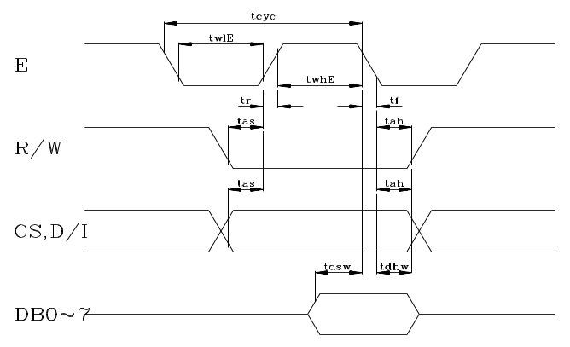 | 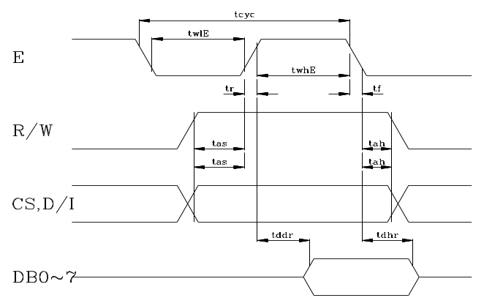

ITEM | SYMBOL | MIN | MAX | UNIT
Enable cycle time | tcye | 1000 | -- | ns
Enable high level width | twhE | 450 | -- | ns
Enable low level width | twlE | 450 | -- | ns
Enable rise time | tr | -- | 25 | ns
Enable fall time | tf | -- | 25 | ns
Address setup time | tas | 140 | -- | ns
Address hold time | tah | 10 | -- | ns
Data setup time | tdsw | 200 | -- | ns
Data delay time | tddr | -- | 320 | ns
Data hold time (write) | tdhw | 10 | -- | ns
Data hold time (read) | tdhr | 20 | -- | ns

9. INSTRUCTION SET
FUNCTION | R/W | D/I | DB7 | DB6 | DB5 | DB4 | DB3 | DB2 | DB1 | DB0 | FUNCTION
1. Display ON/OFF | 0 | 0 | 0 | 0 | 1 | 1 | 1 | 1 | 1 | 1/0 | Controls the ON/OFF of the display. RAM data internal status is not affected. 1:ON, 0:OFF
2. Display start line | 0 | 0 | 1 | 1 | Display start line (0~63) |  |  |  |  |  | Indicates the display data RAM displayed at the top of the screen.
3. Set Page (X address) | 0 | 0 | 1 | 0 | 1 | 1 | 1 | Page (0~7) |  |  | Sets the page (X address) of RAM at the page (X address) register
4. Set address | 0 | 0 | 0 | 1 | Y address (0~63) |  |  |  |  |  | Sets the Y address at the Y address counter
5. Status Read | 1 | 0 | Busy | 0 | ON/  OFF | RESET | 0 | 0 | 0 | 0 | Reads the status.  RESET 1:RESET, 0:Normal  ON/OFF 1:Display OFF, 0:Display ON  BUSY 1:In Operation, 0:Ready
6. Write Display Data | 0 | 1 | Write Data |  |  |  |  |  |  |  | Writes data (DB0~7) into display data RAM. After writing instruction, Y address is increased by 1 automatically.
7. Read Display Data | 1 | 1 | Read Data |  |  |  |  |  |  |  | Reads data (DB0~7) from display data RAM to the data bus.

10. DESCRIPTION OF INSTRUCTIONS
(1) Display ON/OFF
 | R/W | RS | DB7 | DB6 | DB5 | DB4 | DB3 | DB2 | DB1 | DB0
Code | 0 | 0 | 0 | 0 | 1 | 1 | 1 | 1 | 1 | D
The display data appears when D is 1 and disappears when D is 0. Though the data is not on the screen width D=0, it remains in the display data RAM. Therefore, you can make it appear by changing D=0 or D=1.

(2) Display start line
 | R/W | RS | DB7 | DB6 | DB5 | DB4 | DB3 | DB2 | DB1 | DB0
Code | 0 | 0 | 1 | 1 | A | A | A | A | A | A
Z address AAAAAA (binary) of the display data RAM is set at the display start line register and displayed at the top of the screen.

(3) Set page (X address)
 | R/W | RS | DB7 | DB6 | DB5 | DB4 | DB3 | DB2 | DB1 | DB0
Code | 0 | 0 | 1 | 0 | 1 | 1 | 1 | A | A | A
X address AAA (binary) of the display data RAM is set at the X address register. After that, writing or from MPU is executed in this specified page until the next page is set.

- Set Y address
 | R/W | RS | DB7 | DB6 | DB5 | DB4 | DB3 | DB2 | DB1 | DB0
Code | 0 | 0 | 0 | 1 | A | A | A | A | A | A
Y address AAAAAA (binary) of the display RAM is set at the Y address counter is increase by every time data is written or read to or from MPU.
0 1 2 3 4 5 .............................................................................................................................61 62 63
DB0  I  DB7 | PAGE 0 | X=0
DB0  I  DB7 | PAGE 1 | X=1
 | I
DB0  I  DB7 | PAGE 6 | X=6
DB0  I  DB7 | PAGE 7 | X=7
Address Configuration of Display RAM

(5) Status Read
 | R/W | RS | DB7 | DB6 | DB5 | DB4 | DB3 | DB2 | DB1 | DB0
Code | 1 | 0 | BUSY | 0 | ON/OFF | RESET | 0 | 0 | 0 | 0
BUSY: When BUSY is 1, The LSI is in internal operation. No instructions are accepted while BUSY is 1, so you should make sure that BUSY is 0 before writing the next instruction.
ON/OFF: This bit show the liquid crystal conditions ON condition or OFF condition.
When ON/OFF is 1, the display is on OFF condition.
When ON/OFF is 0, the display on ON condition.
RESET: RESET=1 shows that the system is being initialized. In this condition, any instructions except Status Read instruction cannot be accepted.
RESET=0 shows that initializing has finished and system is in the usual operation.
(6) Write Display Data
 | R/W | RS | DB7 | DB6 | DB5 | DB4 | DB3 | DB2 | DB1 | DB0
Code | 0 | 1 | D | D | D | D | D | D | D | D
Writes 8-bit data DDDDDDDD (binary) into display data RAM. The Y address is increased by 1 automatically.

- Read Display Data
 | R/W | RS | DB7 | DB6 | DB5 | DB4 | DB3 | DB2 | DB1 | DB0
Code | 1 | 1 | D | D | D | D | D | D | D | D
Reads out 8-bit data DDDDDDDD (binary) from the display data RAM. The Y address is increased by 1 automatically. One dummy read is necessary soon after the address setting.

11. INITIALIZING AND PROGRAMMING

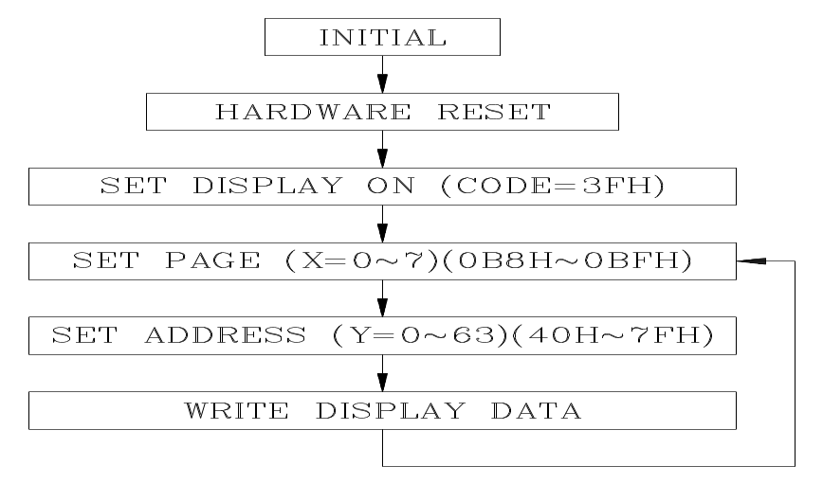

12. Reliability Condition
 |  |  | TN TYPE |  | STN TYPE
 |  |  | Normal Temp. | Wide Temp. | Normal Temp. | Wide Temp.
Viewing  Angle | Horizontal Φ |  | ±30℃ | ±30°℃ | ±30℃ | ±30℃
Viewing  Angle | Vertical Θ(㎜) |  | 10℃ to 30°℃ | 10℃ to 30°℃ | -10℃ to 40℃ | -10℃ to 40℃
Operating Temperature |  |  | -10℃ to 70℃ | -25℃ to 80℃ | 0℃ to 50℃ | *-20℃ to 70℃
Storage Temperature |  |  | -20℃ to 80℃ | -35℃ to 90℃ | -20℃ to 70℃ | *-30℃ to 80℃
High Temperature (Power Off) |  |  | 240 Hours @70℃ | 240 Hours @90℃ | 240 Hours @65℃ | 240 Hours @75℃
Low Temperature (Power Off) |  |  | 240 Hours @-20℃ | 240 Hours @-35℃ | 240 Hours @-15℃ | 240 Hours @-25℃
High Temperature (Power On) |  |  | 240 Hours @70℃ | 240 Hours @80℃ | 240 Hours @60℃ | 240 Hours @70℃
Low Temperature (Power On) |  |  | 240 Hours @-10℃ | 240 Hours @-25℃ | 240 Hours @-10℃ | 240 Hours @-20℃
High Temperature & High Humidity |  |  | 55℃/90%RH  240 Hours | 75℃/90%RH  240 Hours | 45℃/90%RH  240 Hours | 65℃/90%RH  240 Hours
Thermal Shock C  B  5 Cycle  A |  | A | 60min@-20℃ | 60min@-35℃ | 60min@-20℃ | 60min@-30℃
 |  | B | 5min@25℃ | 5min@25℃ | 5min@25℃ | 5min@25℃
 |  | C | 60min@-70℃ | 60min@90℃ | 60min@70℃ | 60min@80℃
Expected Life |  |  | 50,000 Hours | 50,000 Hours | 50,000 Hours | 50,000 Hours
*Wide temperature version may not available for some products, Please consult our sales engineer or representative.

13. Function Test & Inspection Criteria
13.1 Sample plan
Sample plan according to MIL-STD-105D level 2, and acceptance/rejection criteria is.
Base on: Major defect: AQL 0.65 Minor defect: AQL 2.5
13.2 Inspection condition
Viewing distance for cosmetic inspection is 30cm with bare eyes, and under an environment of 800 lus (20W) light intensity. All direction for inspecting the sample should be within 45°against perpendicular line.
13.3 Definition of Inspection Zone in LCD

C

B
A

Zone A: Character / Digit area
Zone B: Viewing area except Zone A ( Zone A + Zone B = minimum Viewing area )
Zone C: Outside viewing area ( invisible area after assembly in customer’s product )
Note: As a general rule, visual defects in Zone C are permissible, when it is no trouble for quality and assembly of customer’s product.
13.4 Major Defect
All functional defects such as open ( or missing segment ), short, contrast differential, excess power consumption, smearing, leakage, etc. and overall outline dimension beyond the drawing. Are classified as major defects.

13.5 Minor Defect
Except the Major defects above, all cosmetic defects are classified as minor defects.
NO. | Item to be Inspected | Inspection Standard |  |  |  |  |  |  |  |  |  |  | Classification of defects
1 | Spot defect  (Defects in spot from) | Zone size (mm) |  | Acceptable Qty |  |  |  |  |  |  |  |  | Minor
1 | Spot defect  (Defects in spot from) |  |  | A |  |  | B |  |  | C |  |  | Minor
1 | Spot defect  (Defects in spot from) | Φ≦0.15 |  | Acceptable (clustering of spot not allowed) |  |  |  |  |  | Acceptable |  |  | Minor
1 | Spot defect  (Defects in spot from) | 0.15≦Φ≦0.20 |  | 1 |  |  | 2 |  |  |  |  |  | Minor
1 | Spot defect  (Defects in spot from) | 0.20≦Φ≦0.25 |  | 0 |  |  | 1 |  |  |  |  |  | Minor
1 | Spot defect  (Defects in spot from) | Φ>0.25 |  | 0 |  |  | 0 |  |  |  |  |  | Minor
1 | Spot defect  (Defects in spot from) | Remarks : for dark/white spot, size Φ is defined as Φ=1/2(X+Y) |  |  |  |  |  |  |  |  |  |  | Minor
2 | Line defect  (Defects in line form) | Size (mm) |  |  |  | Acceptable Qty |  |  |  |  |  |  | Minor
2 | Line defect  (Defects in line form) | L | W |  |  | Zone |  |  |  |  |  |  | Minor
 |  |  |  |  |  | A |  |  | B |  |  | C | Minor
2 | Line defect  (Defects in line form) | Acceptable | W≦0.02 |  |  | Acceptable |  |  |  |  |  | Acceptable | Minor
2 | Line defect  (Defects in line form) | L≦3.0 | W≦0.03 |  |  | 2 |  |  |  |  |  | Acceptable | Minor
2 | Line defect  (Defects in line form) | L>2.5 | W≦0.03 |  |  | 0 |  |  |  |  |  | Acceptable | Minor
2 | Line defect  (Defects in line form) | L≦3.0 | 0.03<W≦0.05 |  |  | 2 |  |  |  |  |  | Acceptable | Minor
2 | Line defect  (Defects in line form) | L>2.5 | 0.03<W≦0.05 |  |  | 0 |  |  |  |  |  | Acceptable | Minor
2 | Line defect  (Defects in line form) |  | W>0.05 |  |  | Counted as spot defect (Follows item 17.5.1) |  |  |  |  |  |  | Minor
2 | Line defect  (Defects in line form) | Remarks: The total of spot defect and line defect shall not exceed four. |  |  |  |  |  |  |  |  |  |  | Minor
3 | Orientation defect (such as misalignment of L/C) | Not allowed inside viewing area (Zone A or Zone B) |  |  |  |  |  |  |  |  |  |  | Minor
4 | Polarizing | 17.5.4.1 Polarizer Position  - Shifting in Position Should not exceed the glass outline dimension.  - Incomplete covering of the viewing area due to Shifting is not allowed. |  |  |  |  |  |  |  |  |  |  | Minor
4 | Polarizing | 17.5.4.2 Scratches, bubble or dent on Glass/Polarizer/Reflector, Bubble between Polarizer & Reflector/Glass: |  |  |  |  |  |  |  |  |  |  | Minor
4 | Polarizing | Size (mm) |  |  | Acceptable Qty |  |  |  |  |  |  |  | Minor
4 | Polarizing |  |  |  | Zone |  |  |  |  |  |  |  | Minor
4 | Polarizing |  |  |  | A |  |  | B |  |  | C |  | Minor
4 | Polarizing | Φ≦0.20 |  |  | Acceptable |  |  |  |  |  | Acceptable |  | Minor
4 | Polarizing | 0.20<Φ≦0.50 |  |  | 3 |  |  |  |  |  |  |  | Minor
4 | Polarizing | 0.50<Φ≦1.00 |  |  | 2 |  |  |  |  |  |  |  | Minor
4 | Polarizing | Φ>1.00 |  |  | 0 |  |  |  |  |  |  |  | Minor

